**AUDITION FOR PRINCIPAL HORN**

**NOVEMBER 6 AND 7, 2025**

This audition is open to candidates of all nationalities.

All candidates must meet the following general requirements:

* Provide proof of civil status
* Enjoy full civic rights
* Be declared medically fit for the profession of musician.

Employment under an open-ended contract (with a three-month probationary period, renewable once). Expected start date: March 2026

Salary (1st category B): €3,860.37 gross per month, for an annualised workload of 75 hours per month

Given the breadth of its repertoire, the Orchestre de chambre de Paris must demonstrate a richness of playing and instrumentation by offering guest soloists and conductors several possibilities of interpretation, demonstrating its openness to all aesthetics.

For the position of Principal Horn, the Orchestre de chambre de Paris regularly proposes the use of natural horns for certain repertoires.

During the tenure period, in order to familiarise themselves with the instrument and demonstrate their expertise, the musicians will be given the opportunity to perform programmes on a natural horn, the instrument being provided by the orchestra.

Submission of a completed application form is mandatory. It must include the following information:

Full name – Date and place of birth – Nationality – Address – Email address – Phone number – Education – Previous and current employment.

A CV may be attached.

Applications must be submitted via the registration form available on our website <http://www.orchestredechambredeparis.com/recrutement/>

Or by post to:

Orchestre de chambre de Paris *Service concours de recrutement* 221, avenue Jean Jaurès

75019 Paris France

## Applications must be received by 27 October 2025

## DATE AND LOCATION OF THE AUDITION:

The audition rounds will take place on November 06 and 07, starting at 8.30 AM (exact schedule to be confirmed later by official summons) at the Philharmonie de Paris, Artists’ Entrance, 191 Boulevard Sérurier, 75019 Paris. (See access map.)

All candidates are required to arrive at the same time for a random draw determining the order of performance.

The jury reserves the right to refuse any candidate who arrives late (after the scheduled call time).

The first round of exams will take place on November 6, 2025.

The second and third rounds will take place on November 7, 2025.

The appointment times for the second day will be set and communicated after the first round.

Candidates are responsible for their own travel and accommodation expenses, as well as those related to rehearsals with the accompanist pianist (each candidate may choose to be accompanied by a pianist of their choice).

The audition rules are available at [www.orchestredechambredeparis.com/recrutement](http://www.orchestredechambredeparis.com/recrutement)

**Map**

**Metro** Line 5 Porte de Pantin station: Direct from Gare du Nord (5 stations) and Gare de l’Est (6 stations).

**Tram T3b** Porte de Pantin station

**Bus** Lines 75 - 151

**Night buses** (**Noctilien)** N13 - N41 - N45 - N140

**Bike sharing** (**Vélib’)** 210, avenue Jean-Jaurès Paris 19 | 3, place de la Porte de Pantin Paris 19

**Car sharing (Autolib’)** 8 rue Adolphe Mille Paris 19| 9 rue des Sept Arpents Paris 19

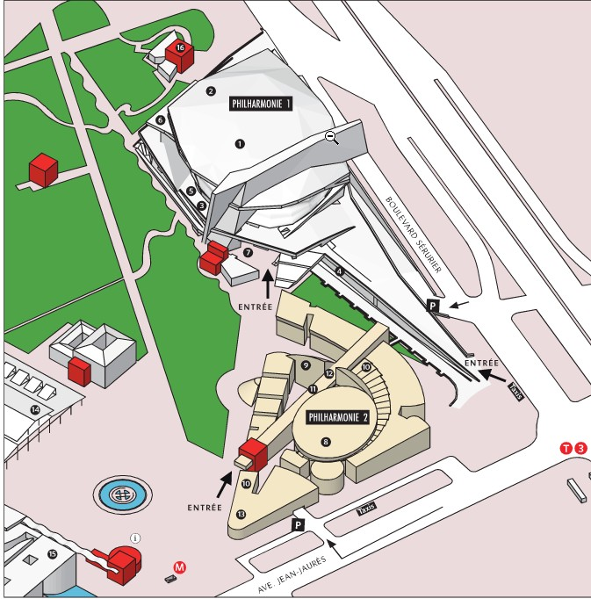

**ARTISTS’ ENTRANCE:**

191 Boulevard Sérurier 75019 Paris